Dear Jo,

We’re now at the point where I would like to move on with getting the program finished and into people’s hands.

In order to do that, I’ve spent some time trying to come up with a detailed description of what I want the program to be able to do for me. I’ve sent this around to a number of people and made sure it makes sense to potential users, and that it says what I actually want.

The fake input screen below shows what I want to be able to store for any star system “out of the box.” I don’t want to have to set these categories up. I want a page of this information automatically available for every star system.

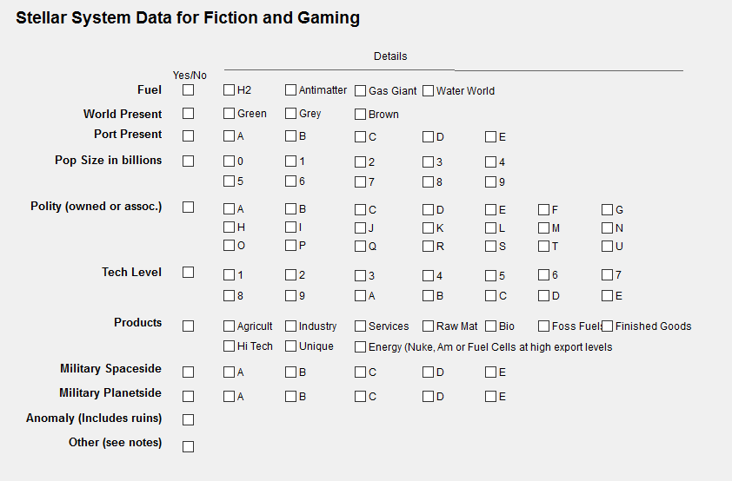

I know I’ll have to import the data from my old system. That’s my problem, but this is the info I want to store and to search on.

For each of the lines on the layout above, if any detail level is checked, then the associated top level yes/no box is also checked automatically. So, if you check Antimatter, then Fuel Available is checked too. However, you can check Fuel Available without checking any detail element: this indicates that *some sort* of fuel is available.

All of the categories allow multiple checkboxes.

Why do I want it this way? First, it works for me, and works the way I think. Second, the codes lean heavily on the coding metrics used by Traveller. Even though they don’t mean exactly the same things, anyone familiar with Traveller will have a roughly accurate feel for what is being indicated with each of these measures. For instance, knowing the rough definition of any given Tech level in Traveller will provide a rough sense of what the alphanumeric values mean here. (The consumer base will have HEAVY Traveller overlap.)

I know from our previous discussions that these are a lot of fields to add to the data, and I recall that you had wanted the next step to be the point at which the data was done changing. So I wanted to be sure that this step was indeed the final step. This is really what I want. I’ve also run different models past potential users: the desire for the check box alternative was almost unanimous.

Now, about using this data

Once these categories and checkboxes exist, then when creating a filter, I want to be able to filter on any of the checkboxes. So, I might want to filter for the yes/no field of fuel – since I may only know that I’ve put some sort of fuel there but not what kind (or I might not care). On the other hand, I would also want to be able to filter on H2, or Antimatter if I wanted to be that specific.

It seems to me that when creating a filter, it should be possible to have a tab or section or something that simply reflects this input form, so I could search for groups of systems just by checking the boxes I want.

This checkbox based filter architecture for searches/displays where we’re not searching on astronomical data but rather fiction/gaming data is much more intuitive. User creativity is now restricted to defining what the different values mean and any special notes. This is the level at which most world-builders want to expend their energy: content creation, not program manipulation. Almost all shied away from relying upon Boolean search requirements (although several did indicate that they were interested in a Boolean key-word search engine for selecting systems based on what the user had entered in their text-note fields as a secondary interest.)

I believe this demographic/system information is sufficient for a star mapping program for fiction and gaming. In addition to searching or filtering on astronomical data such as G spectral types, the check boxes for polity and population and world type & etc. will allow very easy searches/filters.

If I want to be able to show all worlds that were

* Brown
* checked for population regardless of amount
* were part of the Terran polity (T)

all I need to do is go to filters, check 3 boxes, and hit GO or SEARCH or whatever.

Logically the program would display only worlds with these values, and create a list of them.

In the best circumstances, a print option would exist (including printing as a saved PDF). Is that doable?

Thanks for all the great work so far. I hope we can finish this and get a great product into users’ hands.

Chuck

PS: An aside: Ideally, there would be a way to create a user defined label for any of the checkboxes marked a,b,c… I.E.; POLITY “A” = “CONSOLIDATED TERRAN REPUBLIC”. But that’s not really all that important.